**Project Design Phase-II**

**Data Flow Diagram & User Stories**

|  |  |
| --- | --- |
| Date | 10 March 2025 |
| Team ID | SWTID1741256813147528 |
| Project Name | Rhythmic Tunes |
| Maximum Marks | 4 Marks |

**Data Flow Diagrams:**

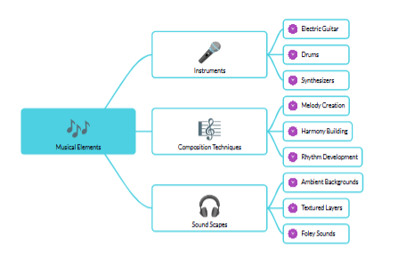

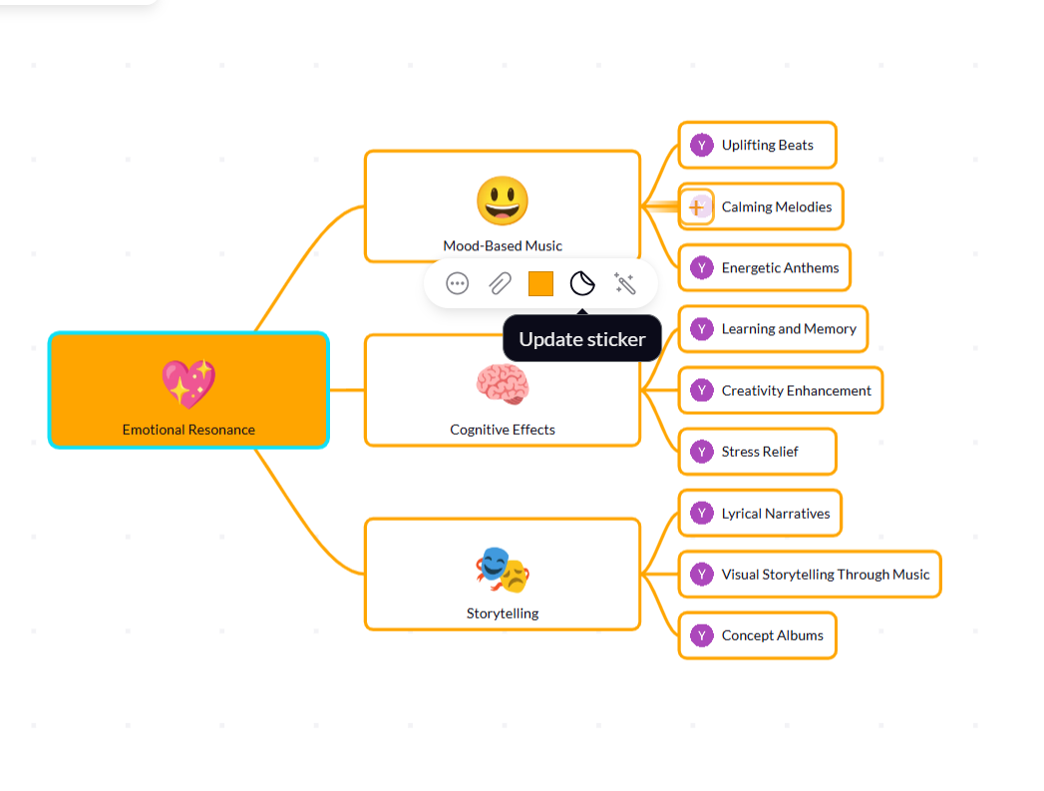

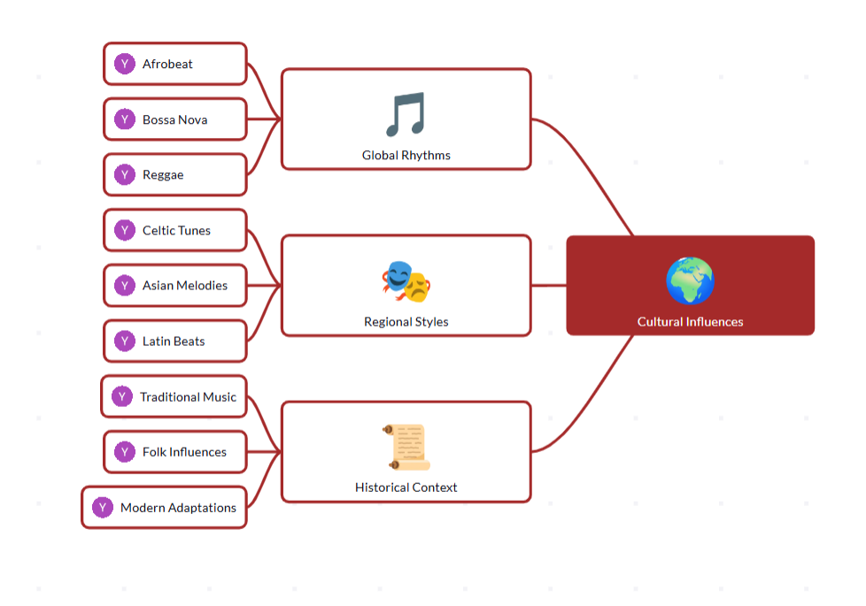

**User Stories**

**User Story Table – Music Streaming App**



         
            
           
           
           
           
           
           
           
           
           
           
           
           
           